Hilink AutoRun tool install user manual

Huawei Technologies Co., Ltd.
All rights reserved

Revision Record

Date | Revision Version | Revision Reason | Section Number | Change Description | Author
2015-10-15 | V1.0 |  |  |  | Product Department Documentation Team
Contents
1 Product Introduction 4
1.1 Install Condition 4
1.2 Install Procedure 4

Product Introduction

Install Condition

Support OS：
- MAC 10.7.x, Mac 10.8.x, Mac 10.9.x, Mac 10.10.x & MAC 10.11.x

Install Procedure

- Unzip the folder of Hilink AutoRun tool, it will like below.
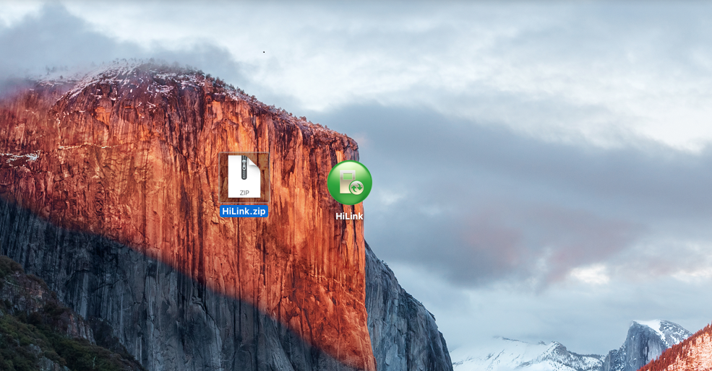
- .Double-click the icon of Hilink, it will install by silent. You can check it install successful or not like below.
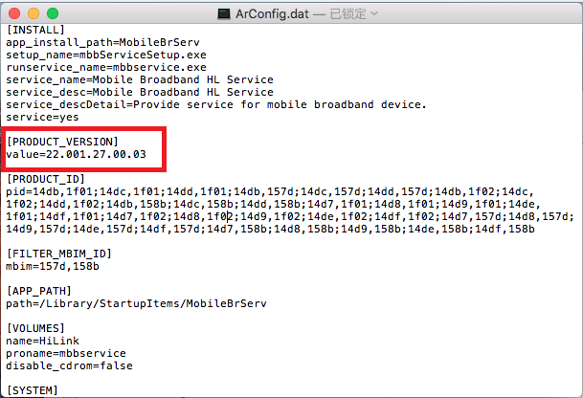
- If the version is change to 22.001.27.00.03, it means Hilink AutoRun tool install successful.

